**Isn’t it crazy to define a method for only one object and then applying that for any object we want?**

**. call () method of function**

Since function is also an object in javascript, so it has a call method.

With the help of it we can write the method for only one object and that method could be used for any object as per our need

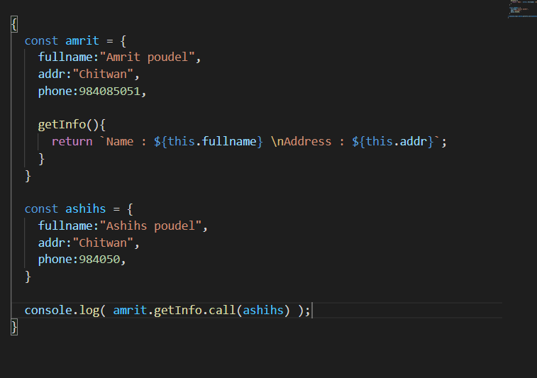

Here getInfo() method is defined in amrit object. So “this” keyword inside it point to the parent of getInfo() function which is “amrit” object.

But since we used .call() method think it that for 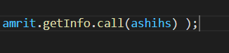 this function call only the parent object of getInfo() became ashihs object

**So in a way through .call() method we can temporarily set the parent of that method() through which we call “ .call() ”method to any object we want**

**combining .call() method with the “arguments” object**

“arguements” object is already present built in, in the function.

We can use this to do further crazier things

like this

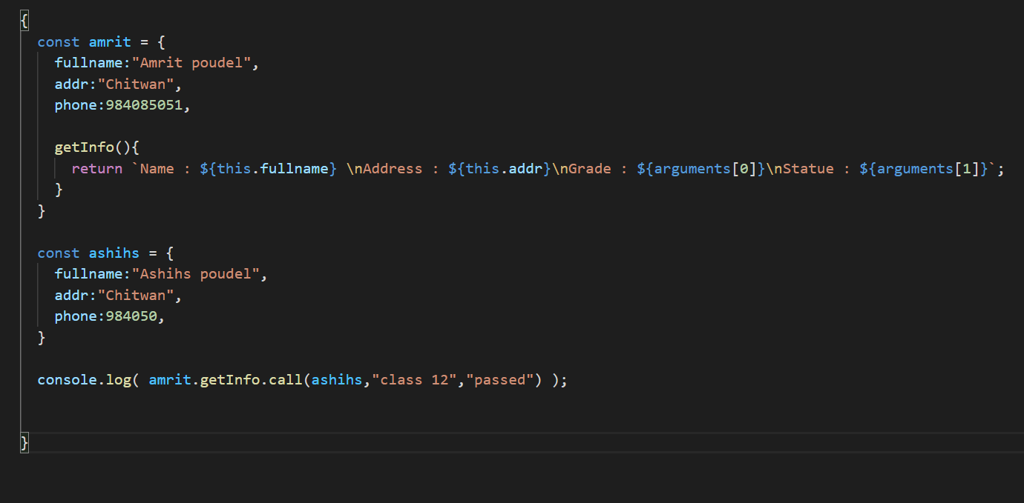

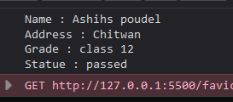

There is also .apply() method available in the functions, which is similar to .call() when we do not pass any arguments

But the difference is that

.call() takes arguments one by one

.apply() takes the arguments inside the array

**Using .apply() method with “arguments” object**

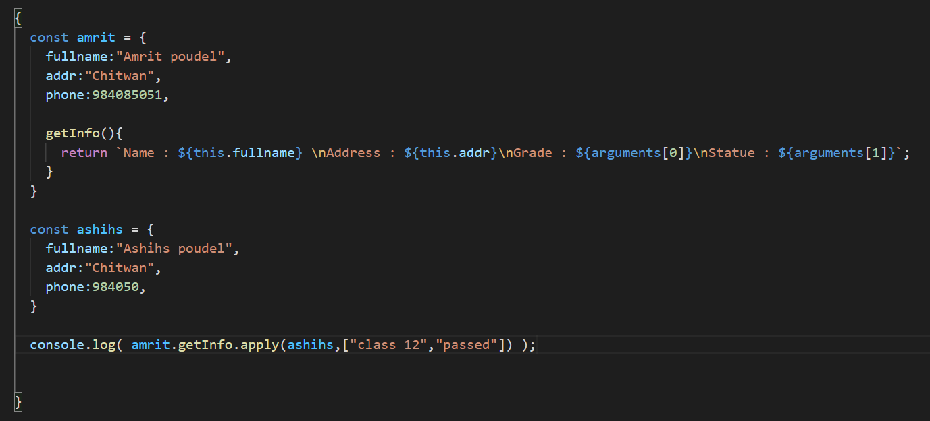

Seems like if we use “arguments” object there is no difference using .call() or .apply()

**We can also apply built in methods of built in objects like Math to any other object we want**

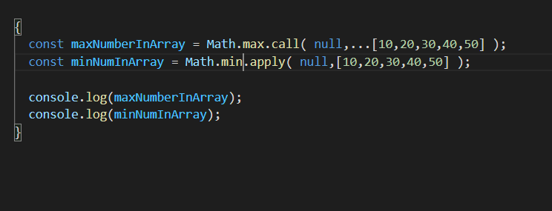



**.call ( ) 🡺 Expects arguments seperatly**

**.apply() 🡺 Expects arguments inside an array**